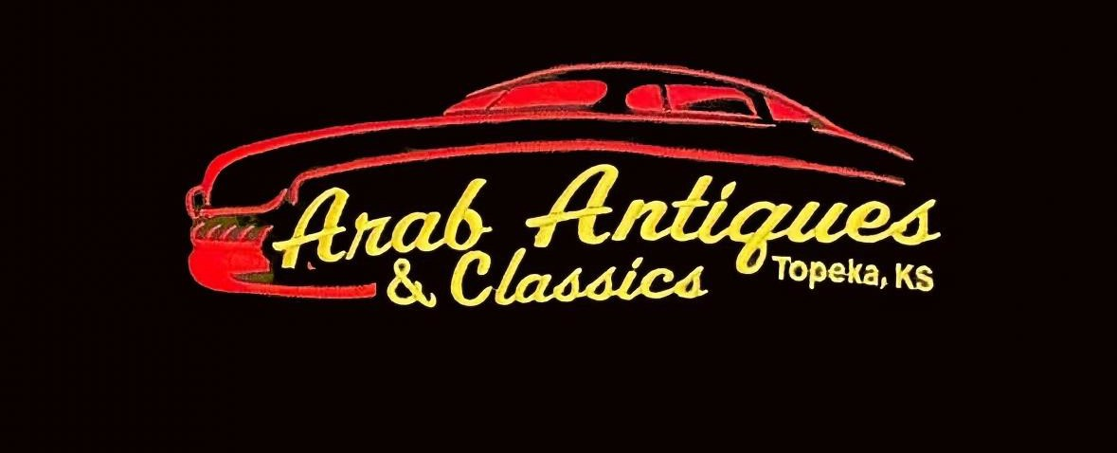

6th Annual Fall Vendor Market and Car Show Arab Shrine, 1305 S. Kansas Ave, Topeka, Ks 66612 (Vendor booths inside building)

October 10, 2026
Registration Deadline October 5, 2025

Booth Fee: 10x10 Space, $25 or Silent Auction Item of equal value 10x20 Space, $50 or Silent Auction Item of equal value
Limited electricity Register at the following link, or scan the QR code. Pay at the door
https://forms.gle/ceWpYbEBxDJqwemC7

